

Abu Dhabi University

EEN 360 - Electronic Devices and Circuits II

Project Report

Designing Wein-Bridge Oscillator

Author:
Supervisor:
Muhammad Obaidullah 1030313
Dr. Riad Kanan
Bilal Arshad 1011929

Section 1

June 2, 2013

Contents

1 | Speci cations |  | 3
2 | Introduction |  | 3
3 | Designing |  | 4
 | 3.1 | Choosing the Right Capacitor for Frequency selective Network . . . . . . . . . . . . | 4
 | 3.2 | Finding the Resistor Values for Frequency Selective Network . . . . . . . . . . . . . | 4
 | 3.3 | Finding the Resistor Values for Appropriate Gain . . . . . . . . . . . . . . . . . . . . | 5
 | 3.4 | Design . . . . . . . . . . . . . . . . . . . . . . . . . . . . . . . . . . . . . . . . . . . . | 6
4 | Simulation |  | 6
 | 4.1 | Frequency Problem . . . . . . . . . . . . . . . . . . . . . . . . . . . . . . . . . . . . . | 6
 | 4.2 | Amplitude Problem . . . . . . . . . . . . . . . . . . . . . . . . . . . . . . . . . . . . | 8
5 | List of Equipment Used |  | 10
6 | Results and Discussions |  | 11
 | 6.1 | Project Testing Set-up . . . . . . . . . . . . . . . . . . . . . . . . . . . . . . . . . . . | 11
 | 6.2 | E ect of Low-Pass Filter . . . . . . . . . . . . . . . . . . . . . . . . . . . . . . . . . . | 11
 | 6.3 | Final Circuit Diagram . . . . . . . . . . . . . . . . . . . . . . . . . . . . . . . . . . . | 11
 | 6.4 | Oscilloscope output . . . . . . . . . . . . . . . . . . . . . . . . . . . . . . . . . . . . . | 12
 | 6.5 | PCB . . . . . . . . . . . . . . . . . . . . . . . . . . . . . . . . . . . . . . . . . . . . . | 12
7 | Cost of Equipment |  | 13
8 | Conclusion |  | 14
9 | Presentation |  | 14
10 | Team Dynamics |  | 14

1

List of Figures

- Original Wien Bridge Oscillator Circuit[1] . . . . . . . . . . . . . . . . . . . . . . . . 4

2 | Frequency Selective Network . . . . . . . . . . . . . . . . . . . . . . . . . . . . . . . | 5
3 | Calculating open loop gain . . . . . . . . . . . . . . . . . . . . . . . . . . . . . . . . | 5

- Before Amplitude Stabilization . . . . . . . . . . . . . . . . . . . . . . . . . . . . . . 9

5 After Amplitude Stabilization . . . . . . . . . . . . . . . . . . . . . . . . . . . . . . . 9

6 These are some of the things that are needed for testing of the circuit . . . . . . . . 10

- The blue wave is the output voltage without low-pass lter and yellow output is with low-pass lter. As we can see, this smooths the output but there is a voltage drop

to compromise for this. . . . . . . . . . . . . . . . . . . . . . . . . . . . . . . . . . . . 11

- This is the nal circuit diagram before building the PCB . . . . . . . . . . . . . . . . 12

9 This is the output from the oscilloscope directly from the PCB output terminal. Here we can see that the output frequency is 18.0 KHz. The wave is appearing somehow triangular because the time divisions are too large. . . . . . . . . . . . . . . . . . . 12

10 This is the nal PCB, the input to the circuit is from the right terminal block where the center input is ground and the other are positive and negative supply for the op-amp. The output is from the left terminal block bottom one being the ground and the top one being the signal. . . . . . . . . . . . . . . . . . . . . . . . . . . . . . 13

2

Abstract

This project report explains in great detail how to design and manufacture a stable Wien Bridge Oscillator and how to improve the design by using amplitude controlling non-linear circuit.

- Speci cations

We had to design, simulate, improve and implement on PCB the Wien Bridge oscillator for the given speci cations:-

The oscillator should output 18KHz frequency. Use diodes 1N4007 for amplitude stabilization. Use ampli er 741.

- Introduction

Oscillator is an electronic device which provides single frequency oscillating signal at the output at a time. A basic oscillator comprises of an ampli er with a frequency selective positive feedback loop. As we all know, any electronic circuit contains di erent types of noises (Thermal noise, White noise, shot noise, etc.) and when these noises pass through an ampli er, its magnitude increases.
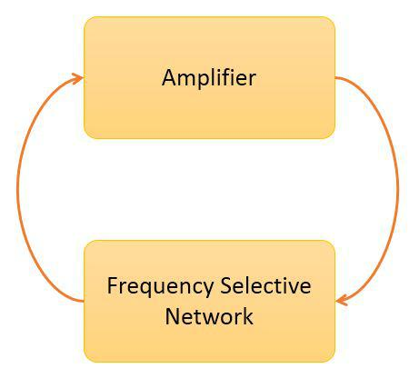

This ampli ed-frequency-mixed signal passes through a frequency selective network and all other frequency components except one fre-quency component are canceled out. This leaves us with one frequency component only, which proceeds into the cycle and gets ampli-ed again by the ampli er. This process repeats on many times a second and we get a single fre-quency wave at the output.

The ampli er we are going to use in this

project is an op-amp 741. The advantage of using an op-amp is that we can put the gain con-trol circuit on the negative feedback and the frequency selective circuit on the positive feedback. Thus, making it easy to control the gain of the ampli er without disturbing the frequency selective network. There are no inputs to the circuit, only supply voltages are provided to the ampli er for it to operate. [3]
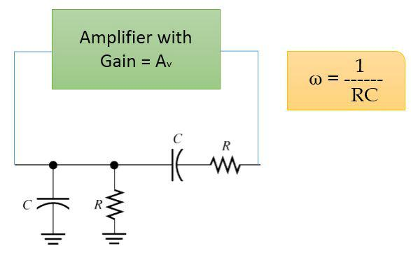

The frequency selective network we are going to use is a typical RC circuit which resonates at the frequency given by

^{f}oscillation ⁼ | 1 | (1)
^{f}oscillation ⁼ | 2 RC | (1)

3

The idea of a frequency selective network is to cut-out all the frequency components except one particular. Resonating circuits exactly do this by always oscillating at the resonance fre-quency given a range of frequencies at the input.

The modern Wien Bridge Oscillator is con-sequence of the circuit originally designed by William Hewlett in 1939. In this circuit he uses a frequency selective network as a positive feed-back to the Op-Amp and uses a electric lamp for amplitude stabilization. When the voltage across the lamp increases, the lamp heats up

Figure 1: Original Wien Bridge Oscillator Circuit[1]
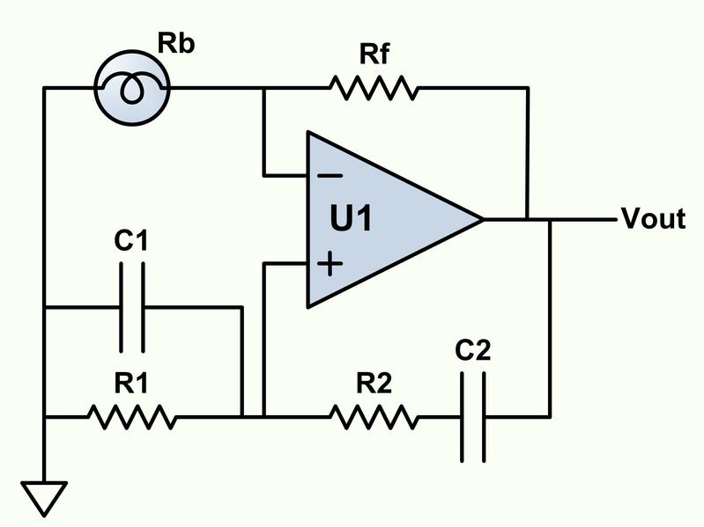

and its resistance increases resulting in decreased loop gain and when the voltage across the lamp is less, the resistance of the lamp is less due to less heating of the lament and the loop gain increases. [2]

- Designing

In order to design a stable oscillator we should follow a number of steps and tackle numerous problems in the following manner

3.1 Choosing the Right Capacitor for Frequency selective Network

Since we are assigned with the frequency of 18 KHz, it will be wise for us to go with the capacitor meeting the following criteria:-

It should be very cheap.

Readily Available in the market. Small in size.

Ceramic capacitor.

For the given frequency, the value of the resistors should be in K range. The capacitor of 1.5nF met all the requirements.

3.2 Finding the Resistor Values for Frequency Selective Network

Now that we have chosen the right capacitor, we can calculate the resistors required for the fre-quency network in order for it to resonate at the required frequency

 | ^{f}oscillation ⁼ |  | 1 |  |  | (2)
 |  |  | 2 RC |  |  | (2)
 | R = | 1 |  |  |  | (3)
 | R = | ² ^{f}oscillation^{C} |  |  |  | (3)
R = |  | 1 |  |  | = 5:9k | (4)
R = | 2 18 10³ 1:5 10 ⁹ |  |  |  | = 5:9k | (4)

4

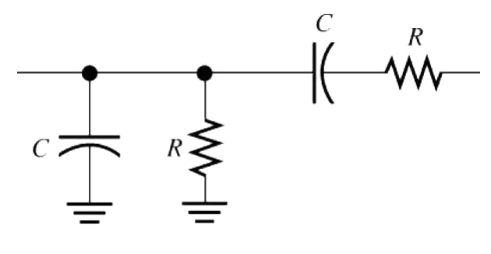

Figure 2: Frequency Selective Network

3.3 Finding the Resistor Values for Appropriate Gain

For this we need to consider the fact that the open loop gain should be more than 3 for the oscillation to start.
A_{v} = | R₄ + R₁ | > 3 | (5)
 | R₁
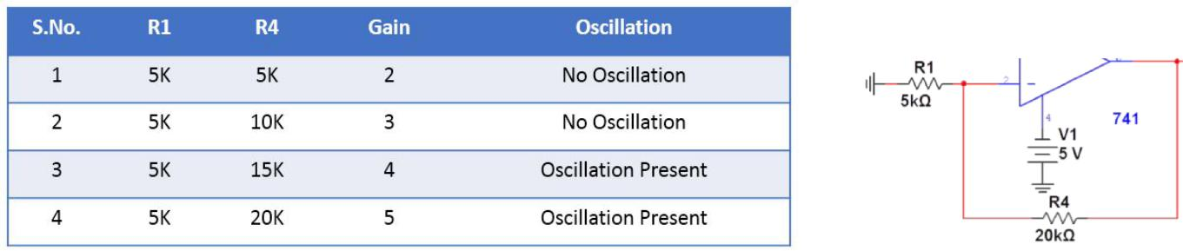

Figure 3: Calculating open loop gain

5

3.4 Design

So nally after calculating all the resistor and capacitor values, we are left with the following circuit
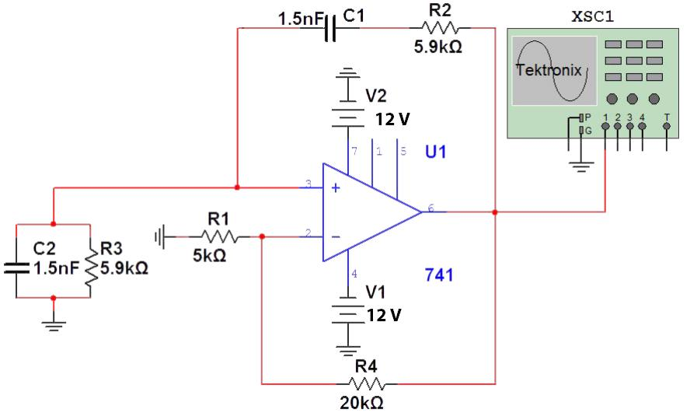

- Simulation

After designing the circuit, we simulated it in Multi-Sim software before implementing the design. This is a good practice as Multi-Sim simulates close to real components and it takes into account some tolerance of components and adds some noise into the circuit for better realistic simulation. The simulation was setup as shown below:-

4.1 Frequency Problem

After running the simulation, we got the sinusoidal wave but it was of 13.5 KHz.

6

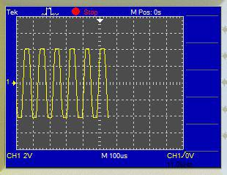

To solve this problem, we decreased the resistor values of frequency selective network to get to the appropriate frequency.
1
^{f}oscillation / _{R} | (6)
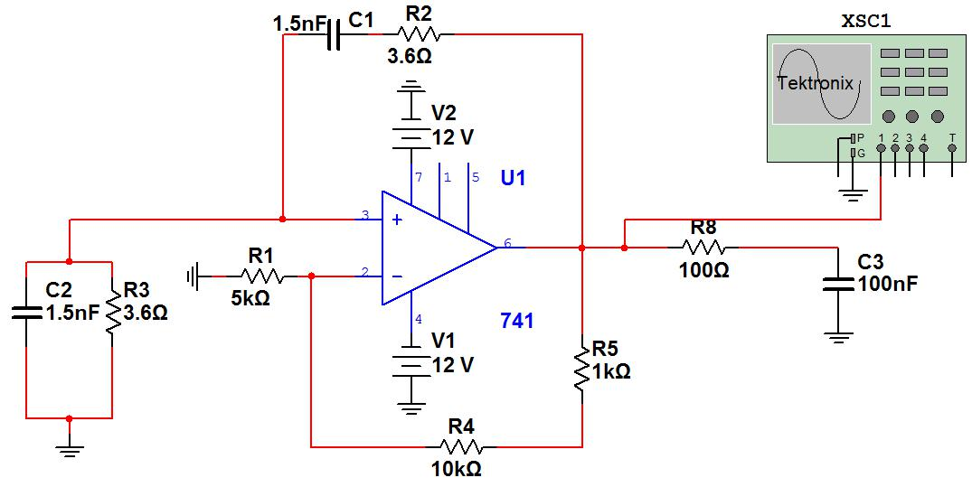

7

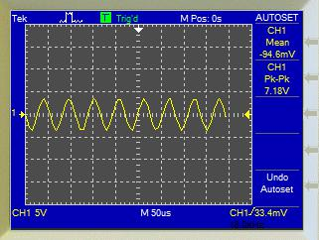

4.2 Amplitude Problem

As we can see that our signal is chopped-o from peaks and is distorted.
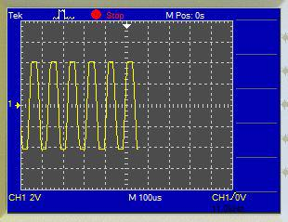

To solve this problem, we introduce a non-linear amplitude control by using diodes to control the gain of the ampli er. The diodes turn "ON"(forward biased) when the output voltage is greater than 0.7V and allow the current to pass through themselves. When this happens, the gain of the ampli er is 3. On the other hand, if the output voltage is less than 0.7V, the diodes are "OFF"(reverse biased) and they do not allow the current to pass through them. Rather the current passes through the 10K resistor and the ampli er gain is about 5. Thus in this way, gain is more for less voltage and less for more voltage making a non-linear ampli er and the output amplitude is stabilized.

8

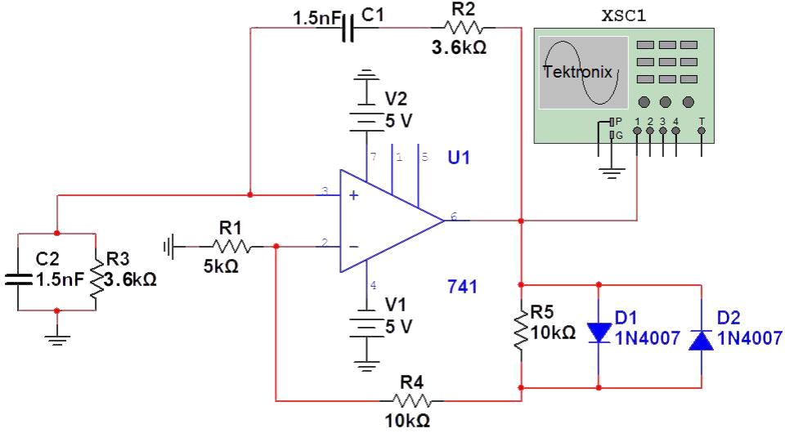
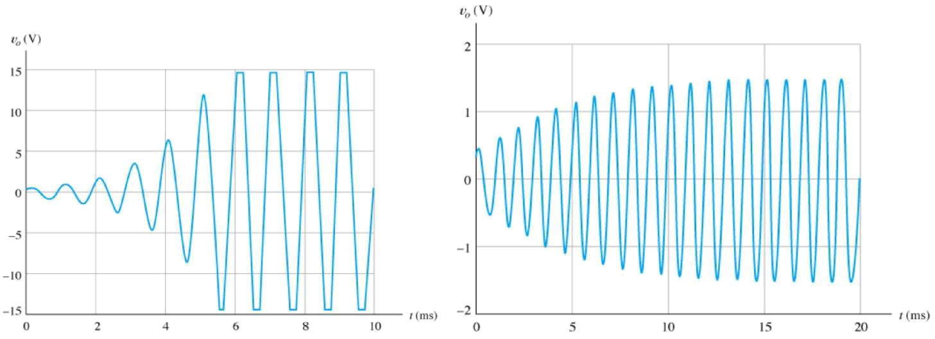

Figure 4: Before Amplitude Stabilization Figure 5: After Amplitude Stabilization

9

- List of Equipment Used

Breadboard. Oscilloscope. Wires.

Resistors and Capacitors. Function Generator.

Function generator cables. Crocodile Clip Cables.

741 OP-AMP IC. Soldering Iron.

Soldering Wire. Solder sucker. Vera-board.

8 pin IC bracket. Variable resistors.
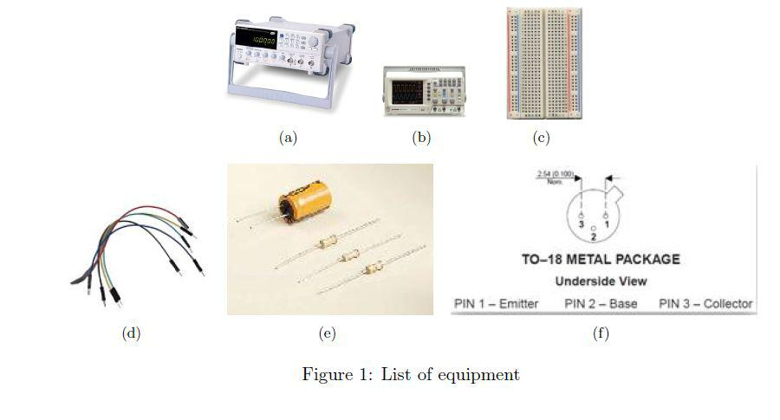

Figure 6: These are some of the things that are needed for testing of the circuit

10

- Results and Discussions

6.1 Project Testing Set-up

In order for us to test the circuit with slightly di erent values of resistors and to allow us to gain control over the output frequency we tweaked the nal circuit in the following manner:

We added a low pass lter at the end of the circuit to further smooth out the wave.

We added 1K potentiometers in series with the existing ones in frequency selective network for gaining control over the output frequency frequency.

A project Test was setup by connecting the +V and -V to variable +V supply and variable -V supply respectively. As we increased or decreased +V, keeping the -V constant, the positive slope of the output increased or decreased respectively. On the other hand, as we increased or decreased -V, keeping the +V constant, the negative slope of the output increased or decreased respectively. The result we concluded was, as we change the supply voltage of the op-amp, the frequency changes. And as the di erence between j + V j and j V j increased, distortion became more prominent.

6.2 E ect of Low-Pass Filter
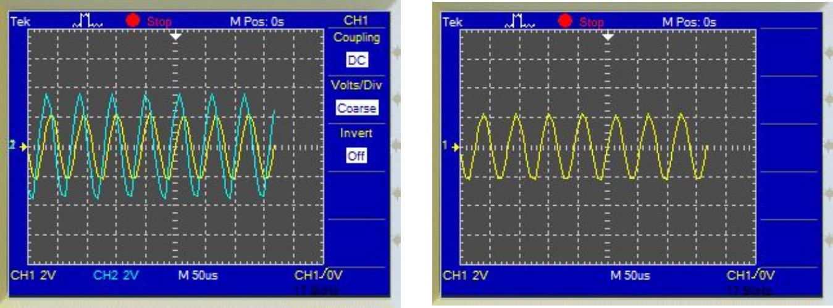

Figure 7: The blue wave is the output voltage without low-pass lter and yellow output is with low-pass lter. As we can see, this smooths the output but there is a voltage drop to compromise for this.

6.3 Final Circuit Diagram

11

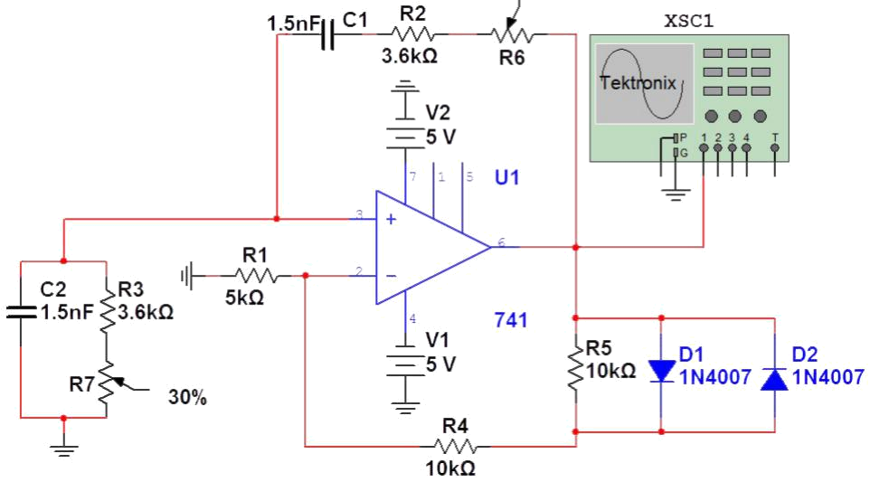

Figure 8: This is the nal circuit diagram before building the PCB

6.4 Oscilloscope output

After we built the PCB, and connected to the oscilloscope it was giving us output frequency of around 17 KHz. We tweaked with the 1K potentiometers until we got exactly 18KHz on the oscilloscope. We got the following result.
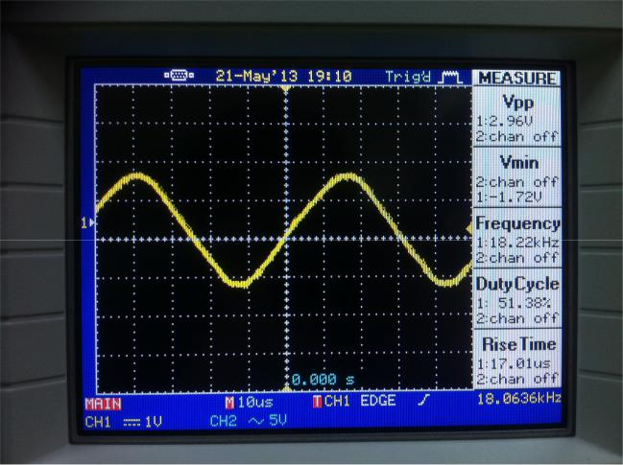

Figure 9: This is the output from the oscilloscope directly from the PCB output terminal. Here we can see that the output frequency is 18.0 KHz. The wave is appearing somehow triangular because the time divisions are too large.

6.5 PCB

12

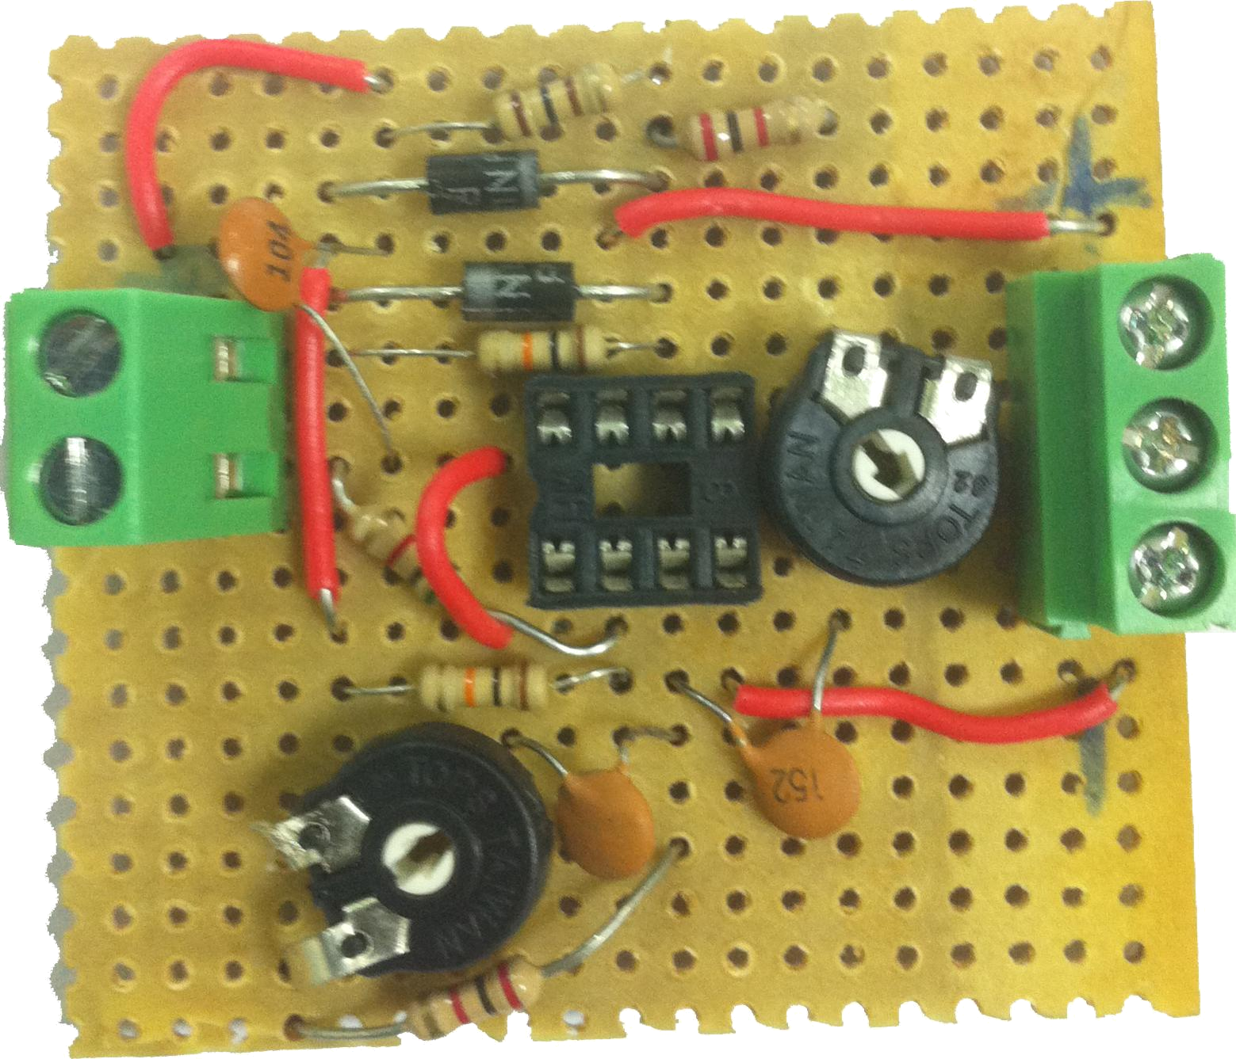

Figure 10: This is the nal PCB, the input to the circuit is from the right terminal block where the center input is ground and the other are positive and negative supply for the op-amp. The output is from the left terminal block bottom one being the ground and the top one being the signal.

- Cost of Equipment

S.No. | Item | No. of Items | Cost
1 | Single Core Wire | 1 meter | 2 Dhs
2 | 8 pin IC mounting bracket | 1 | 1 Dhs
3 | 3K Resistors | 2 | 1 Dhs
4 | 1.5 nF Capacitors | 2 | 1 Dhs
5 | 100 nF Capacitor | 1 | 0.5 Dhs
6 | 100 ohm Resistor | 1 | 0.5 Dhs
7 | 1N4007 Diodes | 2 | 2 Dhs
8 | 10K Resitor | 2 | 1 Dhs
8 | OP-AMP 741 IC | 1 | 4 Dhs
9 | 1K Potentiometer | 2 | 4 Dhs
10 | 3-Terminal Block | 1 | 2 Dhs
11 | 2-Terminal Block | 1 | 2 Dhs
13 | Copper Veraboard | 1 | 8 Dhs
Total |  | 18 | 29 Dhs

13

- Conclusion

Electronic resonating circuits have low accuracy than the crystal oscillators which are readily available in the market. For generating highly accurate and precise frequency, we can replace the feed back frequency selective network with a crystal oscillator. Crystal oscillator contains a crystal which has piezo-electric properties and can resonate to one particular frequency.

Oscillators made up of Op Amp are usually limited to the lesser end of the frequency spectrum, mainly due to the reason that they do not possess the required bandwidth to attain low phase shift on higher frequencies. The Op Amps with current feedback have larger bandwidth in comparison to the voltage feedback Op Amps. However there remains a di culty in practical usage of these due to their sensitivity of the feedback capacitance.

Low pass lter can remove the harsh edges but it consumes power from the signal. Wien bridge oscillator frequency depends on the supply voltage.

MULTISIM simulates close to real components and takes into account some probabilities. Ampli er gain should be above 3 for an oscillation to happen.

Distortion happens if the input voltages (-V and +V) are not equal.

Op Amps with voltage feedback are restricted to a few hundred kHz as a maximum, due to their low frequency roll o . While cascading the bandwidth is reduced because of the multiple contribution of phase shift.

The Wien-bridge oscillator has a small number of parts and ne frequency stability, never-theless the fundamental circuit has high output deformation.

Wein bridge oscillator as a solution the problems we face. AGC improves the deforma-tion signi cantly, predominantly in the lesser frequency range. Nonlinear feedback o ers the paramount presentation over the mid- and upper-frequency ranges.

- Presentation

You can access our presentation from the following link:

https://www.dropbox.com/s/s7klodc27t4j9ss/Electronic%20Circuits.ppt

10 Team Dynamics

Part and Member | Weight Grade | Muhammad Obaidullah | Bilal Arshad
Abstract | 10% | 50% | 50%
Introduction | 15% | 50% | 50%
Procedure Part 1 | 15% | 50% | 50%
Procedure Part 2 | 15% | 50% | 50%
Results Part 1 | 15% | 50% | 50%
Results Part 2 | 15% | 50% | 50%
Conclusion | 15% | 50% | 50%
Total | 100% | 50% | 50%

14

References

- Wikipedia.org "A simpli ed schematic of a Wien bridge oscillator with labels on each compo-nent.", Internet:http://en.wikipedia.org/wiki/File:Wein_Bridge_Oscillator.png, 7 August 2011 [2 June 2013].

- Wikipedia.org "Wien bridge oscillator", Internet:http://en.wikipedia.org/wiki/Wien_ bridge_oscillator, 1 May 2013 [2 June 2013].

- Kumar, Umesh. (2010). Fractional Wien Bridge Oscillator Journal of Active and Passive Electronic Devices. [Electronic]. Vol. 5 (issue 1/2), pages 3-5. Available: http://search. ebscohost.com [2 June 2013].

15

